## 10 Online Shopping Tips To Save Money While Scoring Major Discounts

### 1. Outmaneuver the dynamic evaluating trap

Dynamic valuing is a tricky technique online vendors offer use to demonstrate various costs to various clients as per your area, your perusing and spending examples and current interest of the item. Have you at any point discovered messy modest airfare that went 30% higher when you kept an eye on the following day? That is dynamic estimating in real life. As this method gotten staggeringly advanced, most retailers are impeccably mindful of your value point and may show you a more significant expense contrasted with another person who pays less in online buys.

To get a less one-sided value you should:

clear your perusing history and treats specifically

log out of your records (email, G+, Facebook and so on)

change to undercover mode or better exploit online mysterious perusing with Tor program

pick confined site forms as opposed to being diverted to US

pick less created nations as home to show signs of improvement costs while scanning for airfare

[](https://image.shutterstock.com/image-photo/they-love-shopping-together-450w-1069837169.jpg)

2.**Shop at the correct day**

Regardless of whether it appears to be enticing to spend your apathetic Sunday early evening time perusing around different retailers, don't money out excessively quick. Most stores turn out limits and exceptional arrangements on Wednesdays, Thursdays and Fridays. Be that as it may, Sunday is the greatest day to score modest aircraft tickets with Monday being the most costly, as indicated by Airlines Reporting Corporation who examined more than 130 million residential and global over the time of 19 months. Numbers represent themselves: $432 is the most minimal normal cost for a ticket to go full circle on Sunday; $439 is Saturday's normal, while Tuesday – the previous "least expensive day to purchase airfare" ended up averaging $497.

As indicated by Rather Be Shopping, Tuesday is the greatest day to buy PC and work stations as significant retailers like Dell Home and Hewlett-Packard convey extraordinary coupons each Tuesday. Saturdays are bibliophiles' specials as Amazon and Barnes and Noble dispatch various books on special, focusing on perusers who love going through an end of the week with another fine read.

### 3. Utilize numerous coupon codes deliberately

On the off chance that the site enables you to join various coupons and promotion codes at the checkout, use them organized appropriately. Let's assume you have a promotion code for a 20% markdown and a coupon for 10$, apply 20% promotion code first. That will subtract 20% from the maximum, subsequently you can burrow more investment funds with your $10 markdown coupon.

[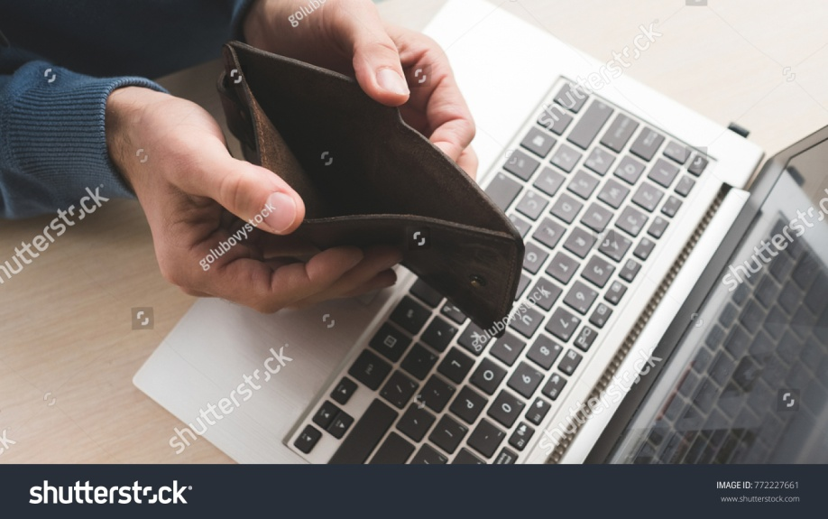](https://image.shutterstock.com/z/stock-photo-internet-scam-fraud-danger-online-man-holding-an-empty-wallet-because-he-lost-his-money-to-a-772227661.jpg)

4. **Request value drop discounts**

Let's assume you've acquired a thing yesterday, however when you checked the following day, it was currently discounted. Entirely baffling, isn't that so? Be that as it may, a few organizations will discount you the value contrast on the off chance that you get in touch with them legitimately inside a specific measure of days. For example, Amazon will give you a discount on the off chance that you tell them inside seven schedule days from the conveyance date. Use Camelcamelcamel.com to screen value changes at Amazon.

Some Visas additionally go with value assurance. That is, regardless of where you shopped – you will discount the distinction if the value plunges inside a specific measure of days. These incorporate Barclaycard Arrival Plus™ World Elite MasterCard®, Citi® Double Cash Card and the sky is the limit from there.

**ALSO READ:-**[***How to save money while shoping online in India***](https://infotech876.blogspot.com/2019/11/how-to-save-money-while-shoping-online.html)

### 5. Exploit savvy remunerate programs

Some applications offer you to reclaim exceptional rewards for doing certain activities. You can acquire kicks by doing paid online reviews or only perusing around item lists with ShopKick that can be traded to gift vouchers or exceptional limits. Swagbucks TV enables you to gain swagbucks for basically watching recordings and recover them as limits from various online shippers.

Case Happy offers 1 point (equivalents to 0.05£) for each pound you spend on their treats – exquisite Ipad, Kindle and tablet covers. Focuses can be reclaimed as coupons with your next request without any breaking points on spending. Fundamentally, you can get the second item for nothing. In the event that you are into planners dress, look at Guilt Insider devotion program. You get early access to deals and a lot of uncommon limits, in addition to you acquire 5 for every dollar burned through, 35 for enjoying them on Facebook, etc. Focuses can be traded with the expectation of complimentary transportation, restrictive access to streak deals and various different advantages. Amazon nails it with Amazon Rewards Visa card with $50 join reward and 3 included for every dollar spent.

[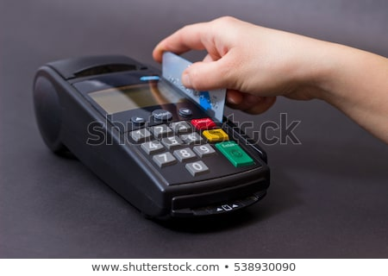](https://image.shutterstock.com/image-photo/hand-swiping-credit-card-store-450w-538930090.jpg)

6. **Deal with the client assistance**

Simply found a delicious coupon at your email to acknowledge it has terminated two days back? Worry not! Ring up the hotline and inquire as to whether your coupon can be stretched out as you are going to make your request. Ordinarily, agents are keen on getting it done and will either give you another promotion code or broaden the current one. It may not work each time, particularly with low-evaluated things, yet it is constantly worth difficult.

On the other hand, you can utilize live time visits now accessible at most sites. Be well mannered and pose a couple of inquiries about the item you'd prefer to purchase and afterward ask if there's any kind of limits they perhaps may have. It is anything but a verifiable truth, however talk backing can give uncommon promotion codes that are not broadly accessible.

7. **Arrange your messages**

Joining to bulletins, coupon locales and advancement records can spare you an enormous bucks, yet you are too hesitant about getting your email spammed? Attempt Unroll.me – a convenient email add-on that lets you in a flash withdraw from garbage messages and de-jumbles your inbox by sending one review email a day condensing your favored memberships. Simply pick the time when you'd prefer to get it.

[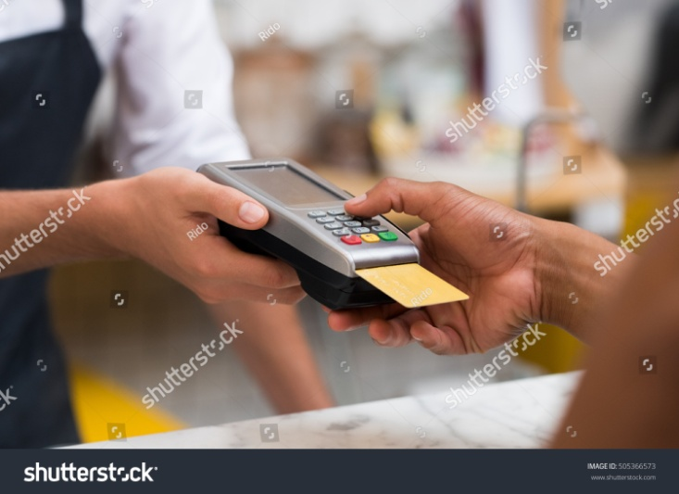](https://image.shutterstock.com/z/stock-photo-close-up-of-hand-using-credit-card-swiping-machine-to-pay-hand-with-creditcard-swipe-through-505366573.jpg)

### 8. Run savvy examination checks

To abstain from overpaying and scoring completely best arrangements on the web, introduce PriceBlink program add-on (accessible for Chrome, Mozilla, Safari). It will spare you huge amounts of time via consequently pulling the costs for a similar item from various traders, arranging them in a brilliant diagram and in any event, telling you if there are any coupons accessible.

Then again, you can attempt Pricegrabber application that does likewise, in addition to can filter standardized tags and give "primary concern costs" that incorporate assessments, transportation and other extra costs.

### 9. Leave things in your truck

Leave the items in your truck and step away for a day or two. Right off the bat, you've recently abstained from making a drive buy. Furthermore, most retailers detest unclosed bargains and will attempt to hold you. Stores that send coupons or offer a superior cost on the following day incorporate Bed Bath and Beyond, Macy's, JC Penney, Office Max and considerably more.

Recall the stunt works just when you have a record on the shipper's site and you are signed in when you leave your truck.

[](https://image.shutterstock.com/image-photo/young-couple-selecting-leather-bags-450w-591166445.jpg)

10.**Gather more coupons with various email addresses**

A few stores love sending enormous single use coupons to a chose gathering of their clients. Increment your odds of sparing truckloads of money by joining to their bulletin with numerous email accounts. Presently envision how a lot of cash you will get with three half markdown codes for one full-evaluated thing buy, rather than one.